Pack of appendices for the full council meeting to be held on Monday 27th July 2026

Appendix | Item | Page no
A | Actions since last meeting | 2
B | Management accounts | 3
C | Orders for payment | 5
D | Internet banking | 6
E | Grant Policy | 7
F | Elections | 8
G | Place Making Plan and grant aid projects | 13

APPENDIX A Actions taken since last meeting:
Ref | Item | Status
1 | Circulate and publish draft minutes | Completed
2 | Pay invoices in line with orders for payment | Completed
3 | Investigate Unity Bank | Completed
4 | Inform PCC of vacant seat | Completed
5 | Complete annual return and external audit | Completed
6 | Progress with place making plan | See minutes
7 | Progress with Deri Woods works – Riverside, drainage and paths | Cllr Rob Astley & Town Clerk
8 | Monitor Leisure Centre | Cllr Gareth Jones
9 | Land registry – Deri Woods | Progressing
10 | Clear undergrowth at:  The vicarage path  Around 20mph signs (Mount Rd/High Str)  Next to no 1 Pool Road | Completed  Completed  To be completed
11 | Investigate new internal auditor | See agenda
12 | Progress Emerging Acorns | Progressing
13 | Progress path Glanyfron to Banwy footbridge | Cllr Gareth Jones & Town Clerk
14 | Chase up highways issues New Road 20mp to end of Deri Woods | Completed
15 | Progress planning for MUGA | Completed
16 | Issue letter of intent to MUGA contractor | Completed
17 | Progress planning for woodland walk opposite Deri Woods car park | Progressing
18 | Appoint contractors for Goat Field | Completed
19 | Rhiweniath Community Centre lease progress | Progressing
20 | Progress with memorial garden St Mary’s | Progressing
21 | Complete transfers between council and trusts (Mount Field\Deri Woods | Completed

APPENDIX B
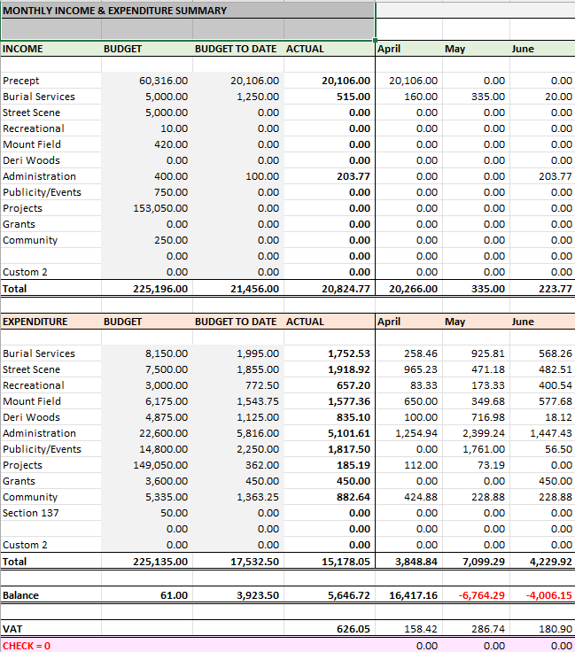

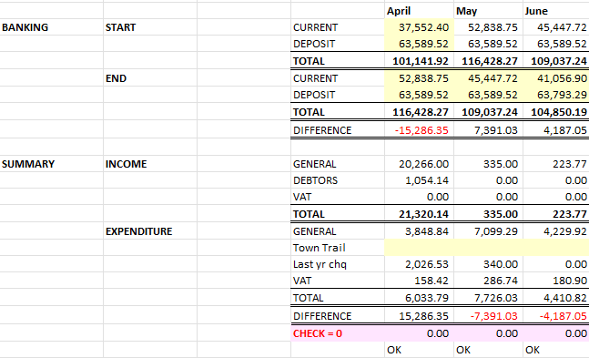

APPENDIX C

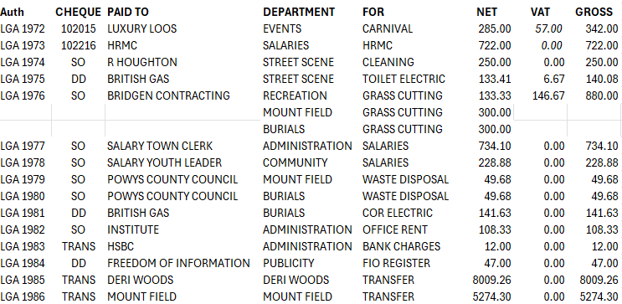

APPENDIX D

Unity banking
Unity Bank is an Australian member-owned bank offering a wide range of financial products and services while prioritising member interests over shareholder profits.

Ownership
Historically, Unity Trust Bank was majority owned by individual trade unions and federations (73.23%) and The Co-operative Bank owned the remainder (26.7%) through its subsidiary, Co-operative Commercial Limited.^{[2]} In 2015, Unity bought back shares from Co-operative Commercial Limited, which reduced The Co-operative Bank's holding to 6.7%.

Unity Trust's new articles of association redesignated all shares into a single class, all ranking pari passu, and removed the different rights of the old classes and created additional shares. As a result, new shareholders have invested in Unity Trust and the Cooperative Bank no longer has a controlling interest or the right to appoint directors.

The Co-operative Bank's stake was put up for sale in 2014, in an attempt to restore Coop Bank's profitability following a capital shortfall.

Getting the account in place
All the signatories can sign up online to register and get a bank account up and running.

Alternative
The alternative is that we continue with HSBC with all signatories attending with the bank at the same time. In this way we could set up a similar arrangement within the timescales that the bank gives us. The timescales have been the made issue when trying to put it all together up to now. This can be done in person whereas Unity Bank is all online.

APPENDIX E
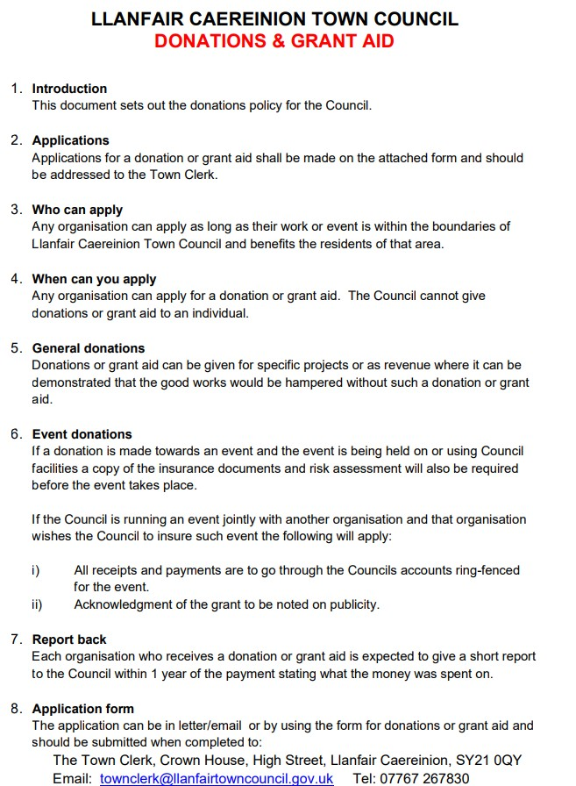

APPENDIX F

Elections and co-option

INTRODUCTION

1.1 This policy sets out the procedure to ensure there is compliance with legislation and continuity of procedures in the co-option of members to the Town Council. The co-option procedure is entirely managed by the Town Council and this policy will ensure that a fair and equitable process is carried out.

1.2 Whenever the need for co-option arises Llanfair Caereinion Town Council will seek and encourage applications from anyone in the Town who is eligible to stand as Town Councillor. Councillors or parishioners can legally approach individuals to suggest that they might wish to consider putting their names forward for co-option.

1.3 The Town Council will advertise the vacancies in the local area via the Town Council noticeboard, the Town Council website, local press releases and a media release if time allows.

1.4 The advertisement to co-opt will include:
- The method by which applications can be made;
- The closing date for all applications;
- A contact point to obtain more information;
- Show that further information is available electronically via the website.

1.5 The co-option policy will be reviewed every 5 years.

CO-OPTION (Stage 1)

2.1 The co-option of a Town Councillor occurs when a casual vacancy has arisen on the Council and no poll (by-election) has been called.
A casual vacancy occurs when:
- A councillor fails to make his declaration of acceptance of office at the proper time;
- A councillor resigns;
- A councillor dies;
- A councillor becomes disqualified; or
- A councillor fails for six (6) months to attend meetings of a council committee or subcommittee or to attend as a representative of the Council a meeting of an outside body.

  - The Town Council must notify Powys County Council of a Casual Vacancy and then advertise the vacancy and give electors the opportunity to request an election.

This occurs when ten (10) electors write to Cornwall Council stating that an election is requested.

  - If a by-election is called, a polling station will be set up by Powys County Council and the people of Llanfair Caereinion will be asked to go to the polls to vote for those candidates who have put themselves forward by way of a nomination paper.

The Town Council will pay the costs of the election.

The people of the Llanfair Caereinion Town Council area will have fourteen days (not including weekends, bank holidays and other notable days), to claim the by-election, but the electoral officer will advise the Clerk of the closing date.

  - If more than one candidate is then nominated a by-election takes place but if only one candidate is put forward they are duly elected without a ballot.

  - If ten residents do not request a ballot within fourteen (14) days of the vacancy notice being posted, as advised by Powys County Council, the Town Council is able to co-opt a volunteer.

  - On receipt, of written confirmation, from Powys County Council Electoral Services, the casual vacancy can be filled by means of co-option.

The Town Clerk will:
- Advertise the vacancy for four weeks on the Council notice boards and website’
- Advise the council that the co-option policy has been instigated.

CO-OPTION (Stage 2)

3.1 Insufficiency of candidates at an ordinary election also provide the Town Council with authority to exercise its rights to co-opt any person or persons to fill any vacancies within 35 days following the date of said ordinary election.

ELIGIBILITY OF CANDIDATES

4.1 The Town Council can consider any person to fill a vacancy provided that:
- he/she is an elector for the community; or
- has resided in the community for the past twelve months or rented/tenanted land in the community; or

- had his/her principal place of work in the community; or • has lived within three miles (direct) of the Ward boundary.

4.2 There are certain disqualifications for election, of which the main are (Local Government Act 1972):
- bankruptcy;
- having been sentenced to a term of imprisonment (whether suspended or not) of not less than three months, without the option of a fine during the five years preceding the election; and
- being disqualified under any enactment relating to corrupt or illegal practices.

  - Eligibility of the candidate(s) will be confirmed by the Clerk.

  - All eligible candidates shall be invited, by letter, to attend the next full Town Council meeting following the application deadline. If candidates are unable to attend, this meeting will not be rearranged but still held on a normal council meeting date.

APPLICATIONS

5.1 To assist candidates Appendix A provides a guide of those criteria that the Town Council would expect from Town Councillors. This is not an exhaustive list but provides candidates with guidance on areas they may wish to include in their application forms.

5.2 Candidates will be requested to:
- Confirm their eligibility for the position of Councillor within the statutory rules, (a copy of the Eligibility Form is attached at Appendix B).
- Submit information about themselves, by way of completing a short application form (a copy of the application form is attached at Appendix C).
Following receipt of applications, the next suitable council meeting will have an agenda item 'To receive written applications for the office of Town councillor and to Co-opt a candidate to fill the existing vacancy'.

5.3 Copies of the candidates’ applications will be circulated to all Councillors by the Clerk at least 3 clear days prior to the meeting of the full Council, when the co-option will be considered. If 3 days is not practicable, due to the timetable laid down by Powys County Council for co-opting, information will be circulated to allow sufficient time for Councillors to consider all applications. All such documents will be treated by the Clerk and all Councillors as Strictly Private and Confidential.

AT THE CO-OPTION MEETING

6.1 The candidates together before proceeding commence at the meeting will have the process explained to them.
Each candidate will be asked to retire except for when they give their short presentation as below.
When all candidates have completed their presentation they will all be invited back into the meeting for the remainder of the proceedings.
After presentations, members may ask candidates a few questions.

6.2 At the co-option meeting, candidates will have five minutes to introduce themselves to members, give information on their background and experience and explain why they wish to become a member of the Town Council;

6.3 If a candidate is unable to attend the meeting, this process will still take place and voting will subsequently be based on this meeting and the application form. (ie the candidate will have to rely on their application form).

The process will be carried out in the public session and there will be no private discussions between members prior to a vote being taken.

6.4 If a candidate is a relative of a Councillor, that Councillor should declare a prejudicial interest and withdraw from the meeting. As soon as all candidates have finished giving their submissions, the council will proceed to a vote. The rules for voting in para 8 of the Council Standing Orders will not apply.

The vote shall be by secret ballot.
There is no provision for a recorded vote.

6.5 In order for a candidate to be elected to the Council, it will be necessary for them to obtain an absolute majority of votes cast (50% + 1 of the votes available at the meeting) subject to the process set out in 6.5 above.

6.6 If there are more than two candidates and there is no candidate with an overall majority in the first round of voting the candidate with the least number of votes will drop out of the process. Further rounds of voting will then take place with the process repeated until a candidate has an absolute majority.

6.7 Only Town Councillors present at the meeting may vote upon a person to fill the vacancy.
Councillors will have one vote per vacancy to be filled.
The Chair has the casting vote.
6.8 The Clerk will notify Electoral Services of the new Councillor appointment, initiate ‘acceptance of office’ paperwork and ‘registration of interests’ within 28 days of being elected.

6.9 If insufficient candidates come forward for co-option, the process should continue, whereby the vacancies are again advertised.

6.10 If there is more than one vacancy and the number of candidates equals the number of vacancies, all the vacancies may be filled by a single composite resolution. However, if the number of candidates exceeds the number of vacancies each vacancy must be filled by a separate vote or series of votes.

6.11 The Council is not obliged to fill all vacancies, but must take steps to advertise for further co-options or hold an election (where applicable) to fill vacancies.

6.12 Any candidate(s) found to be offering inducements of any kind will be disqualified.

ELECTED COUNCILLORS (CO-OPTION)

7.1 Successfully co-opted candidates become Councillors in their own right, with immediate effect, and are no different to any other member.

7.2 Co-opted members will be asked to sign a Declaration of Acceptance of Office to agree to be bound by the Local Government Code of Conduct.
They may then take their seat at Council and are then able to be appointed to a committee and/or as a representative to local organisations.

7.3 Any application can be considered in a candidate(s) absence, but if successful, members would need to agree for him/her to sign the Declaration of Office either before or at the next Council meeting.

APPLYING FOR A CASUAL VACANCY

8.1 Candidates who are interested in applying for a casual vacancy need not wait until the notice appears (co-option, stage 2) or its time limit expired. Candidates can write to the Town Council directly expressing their interest in the casual vacancy and request it considers their application when it has authority to co-opt for the vacancy.

EQUALITY
The Council will consider any person with a disability including dyslexia and will ensure that provision is made at Council Meetings for such members.

R A Robinson Town Clerk April 2022

APPENDIX G

Place Making Plan and grant aid projects
UPDATE

Grant | Amount | Project
Shared Prosperity Fund  (Place Making Plan) | £83,000 | MUGA PITCH  Planning application prepared and ready to be submitted.  MUGA tender process complete and preferred contractor informed with letter of intent.  Price for both 18mx24m pitch and groundworks awaited.  Drainage (SAB) plans – instructions given.
Transforming Towns  (Deri Woods/Goat Field) | £33,500 | RIVERSIDE PATH  Meetings with some contractors completed.  Awaiting formal prices.  WASHED OUT PATH/DRAINAGE  Meetings with some contractors completed.  Awaiting formal prices.  ENTRANCE TO GOAT FIELD  Contractor instructed, awaiting start date. When work starts width of path for gates construction can be identified.
Emerging Acorns  (Deri Woods) | £10,000 | PATH CAR PARK-RIVERSIDE  Information required by grant funder issued, they are taking the project forward for us.
Emerging Acorns  (Deri Woods) | Undefined | REVISION TO 2016 WILDLIFE TRUST PLAN  Information required passed to funders, they will arrange for the review liaising with the Town Clerk.
Emerging Acorns  (Deri Woods) | Undefined | SCULPTURE AND EVENT  Awaiting plan from funders as to what they can do for us. They would like the council to identify a contractor who can do the work. Town Clerk has posted on social media and the website seeking interest from contractors.
PAVO  (Town Guide) | £1,250 | TOWN GUIDE DESIGN AND PRINT  At design stage.
MFU  (Sculpture/seating) | TBC | SCULPTURE AND SEATING  Grant yet to be finally confirmed but may cover refurbishment/replacement of the sculpture and seating to surround the grassed area.

